Milestone 5
Create onCellEdit Client Script

Objective
Create an onCellEdit Client Script to prevent direct changes to the State field through Incident list editing.

Activity 1 – Create Client Script
- Navigate to System UI → Client Scripts.
- Click New.
- Configure the Client Script.
- Paste the script into the Script field.
- Click Submit to save the Client Script.
- Open the Incident list and try to edit the State field directly.

Client Script Configuration
- Name: Prevent state change via list edit
- Table: Incident
- Type: onCellEdit
- Field name: State
- Active: true

Script
function onCellEdit(sysIDs, table, oldValues, newValue, callback) {
alert('State cannot be updated using list editing. Please open the Incident.');
callback(false);
}

Expected Result
When the State field is edited directly from the Incident list, an alert is displayed and the change is blocked.
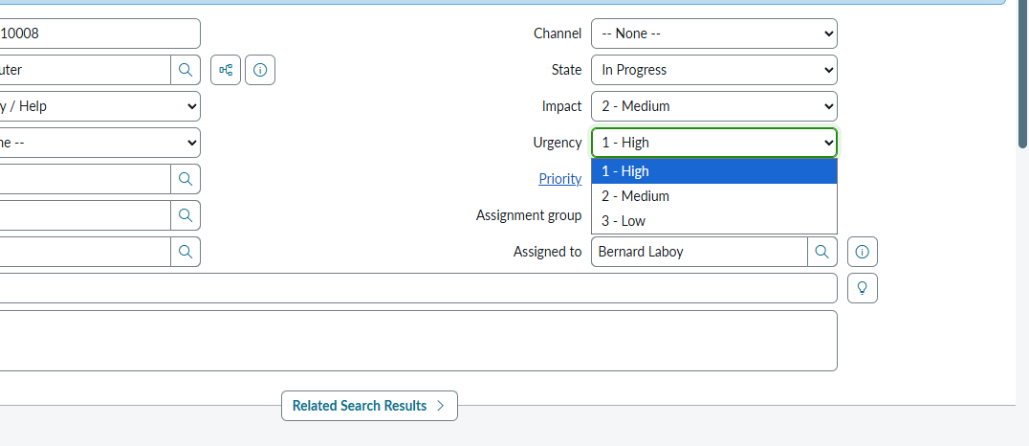
Place the screenshot showing the list-edit blocking behavior here if desired.

